You have the option to register from a saved schedule or register individual courses.
It is recommended to register from a saved schedule to ensure you get the classes you need to graduate. Since you can register all the classes in your saved schedule as a group, saved schedules help you save time, secure a seat in popular classes, and avoid errors in your registration.
Prepare your saved schedule before registration begins with help from your advisor.

Use this reference to:
- Register from your saved schedule (recommended)
- Register for individual classes

TIP: To register from your saved schedule, you must already have a saved schedule prepared. If you do not have a saved schedule, meet with your advisor.

Register from a Saved Schedule
- Log into Workday and click the Academics app.

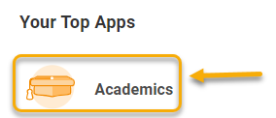

- In the Academics app, click “View My Saved Schedules” under the Registration heading.
If you do not have a saved schedule, meet with your advisor.



On the View My Saved Schedules page, select the academic period associated with your saved schedule and click “OK”.
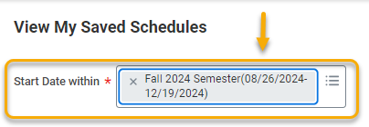

You will see your saved schedule for the selected academic period. If you are not eligible to register for a particular class, or if it has reached capacity, you may receive an alert.

Take a moment to review the course sections on the saved schedule. Make any changes here. See below for a description of editing options.

Button | Description
View Calendar   | View and/or download your saved schedule in calendar view. This is a helpful tool to determine whether the schedule is a good fit for you.  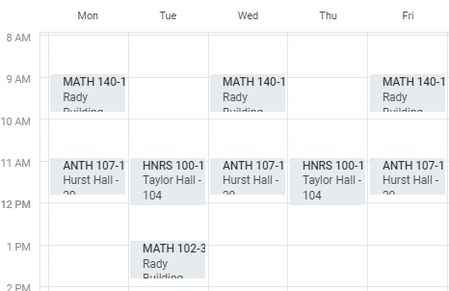
Add Course Sections   | Return to the course search and add additional course sections to the saved schedule. Before adding a new course, be sure the meeting time does not conflict with a course already in your schedule. It is recommended to click “Add Course Sections” and open in new tab so that you can easily return to your saved schedule.
Edit   | Remove a course, select a different meeting time, or change the name of your saved schedule.
Remove   | Delete the saved schedule completely.

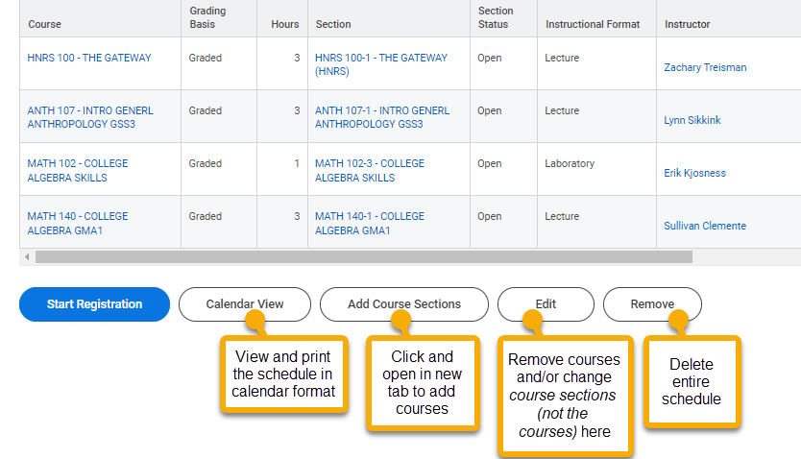

When you are ready to register, click the “Start Registration” button.



Click “Register”.


You will receive one or more of the following messages:
Registration status | Description
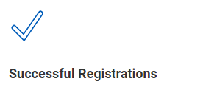 | This means you are successfully registered for the courses listed underneath this image. To view your registered courses, click the “View Registered Courses” button.  
 | This means you are waitlisted for the courses in the corresponding Waitlisted Courses table.  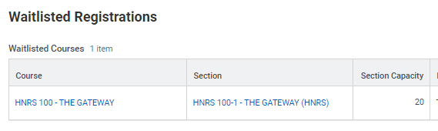
 | This means you are not successfully registered for the courses listed in the corresponding Not Registered Course table. This is usually a result of an unmet prerequisite. You may submit a prerequisite override request to the instructor through Workday.

Register for an individual class
- Log into Workday and click the Academics app.



- In the Academics app, click “Find Undergraduate Fall Course Sections” or “Find Graduate Fall Course Sections”.

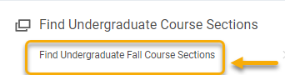

- Using the course search features, locate the course section for which you want to register. Right click the course to open in a new tab.

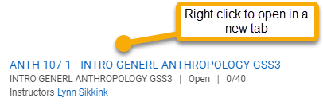

- The View Course Section page will display course details. Review carefully to ensure you are eligible and do not have schedule conflicts.

If you are not eligible to register for the course, you may see the Add to Saved Schedule and Troubleshoot buttons.

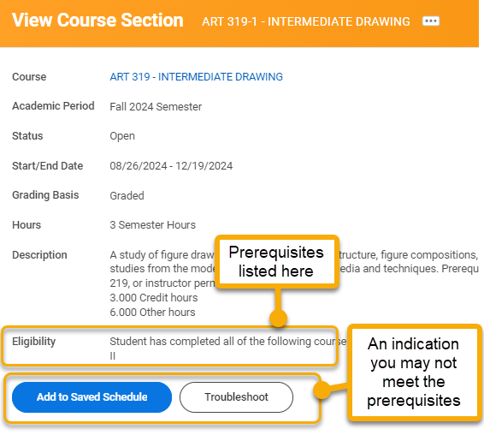

If you are eligible to register, Workday will display the “Register” button.

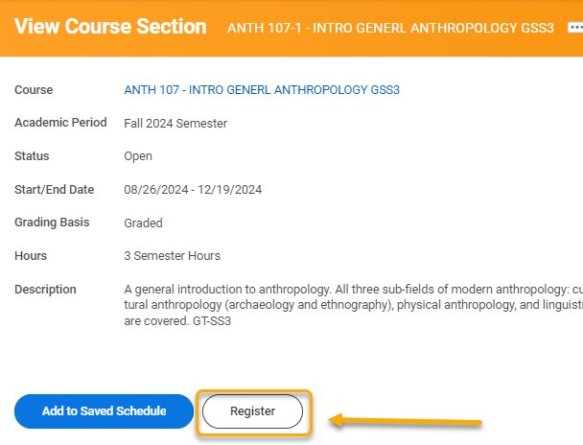

- Click “Register”.

- On the Register for Course Section page, the course sections available will appear. Select the course section with your preferred meeting pattern and confirm the box in the Eligible column is checked.

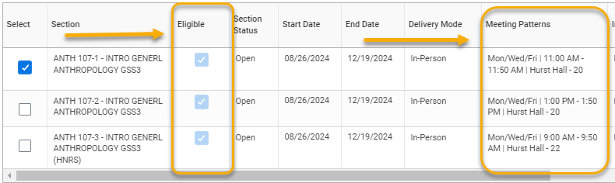

- Click “Register”



You will receive one or more of the following messages:

Registration status | Description
 | This means you are successfully registered for the course. To view all your registered courses, click the “View Registered Courses” button.  
 | This means you are waitlisted for the course.  
 | This means you are not successfully registered for the course. This may be the result of an unmet prerequisite, account hold, or schedule conflict. Reach out to your advisor for help.

